Grizzly Gazette

What’s Happening in Second Grade: Rainforest Mania
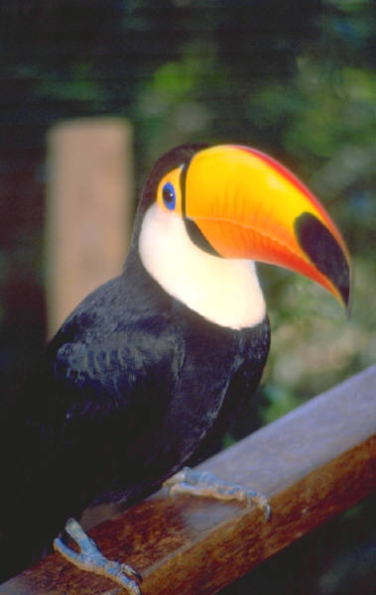
The toucan is one of the rainforest animals we learned about this week.
This week Second Grade began learning about the rainforest. All of our subjects were centered around learning about the rainforest. Together we learned about different animals of the rainforest, the climate of the rainforest, the different layers found in a rainforest, and about the indigenous people who make their homes in the rainforest. Activities we did included making animal books, reporting to our friends about the animal we researched, reading books about the rainforest by Lynne Cherry, and doing Rainforest Math Problems. Next week we will continue to learn more about the rainforest. One activity we will be working on is our Rainforest Poetry. By Friday we hope to end our Rainforest unit with a Snake Cake and Alligator juice along with some fun rainforest games.

Miss Horne’s Bragging Board
Miss Horne is very proud of her class and enjoys using her Bragging Board, to brag on her second graders. This week I noticed several of the boys opening doors for the girls. Boys, that shows great manners and I like knowing that you know how to show respect for others. I also noticed several of the girls working hard to get along with each other. In class we discussed how it is sometimes hard to get along with each other. As a class we talked about being patient and thinking positive things about people rather than negative things. Thank you second grade for all of your good behavior!
- Miss Horne

Second Grade Showcase
This week in art we helped Miss Horne paint her chairs. Together we painted the chairs and made our own unique and creative design. The chairs represent us as unique individuals who can each contribute something different to the class. Together we can make a beautiful design just like we did on our chairs. , Each chair is special just like us.

Volume 1 Issue 1
August 25, 2005
Inside this Issue
-What’s Happening
-s Bragging Board
-Second Grade Showcase
-Joke of the Week
-Author’s Chair
-Note to Parents
-Homework
-Menu

Joke of the Week
Doctor, doctor I keep forgetting things.
What was that? What was what?!

I would replace the clipart above with a picture of the kids and their chairs talked about in “Second Grade Showcase” In this textbox I would write their names or some kind of caption related to the picture.

Author’s Chair: My Trip to the Zoo
Feature Author: Taylor Adams
This week’s story is written by Taylor Adams.
It was a hot July morning when my mom woke me up to get ready to go to the zoo. My brothers and I hurried to get ready to go and then jumped into the car.
Mom and Dad drove us to Oklahoma City where the zoo was. Once we got there, we bought some peanuts to feed the elephants.
As I walked though the zoo I saw monkeys, giraffes, lions, bears, elephants, flamingos, and alligators. My favorite part of the zoo was the monkeys. I liked to watch them swing through the trees.
At the end of the day I was really tired. The hot sun and all that walking wore me out. On the way home I fell asleep. When I woke up it was the next day and I was ready to start a new adventure.
Above I would replace the clipart with a picture of Taylor at the zoo. In this text box, I would have a caption related to the picture.
Breakfast and Lunch Menu
Monday: Wednesday Friday
Breakfast– Biscuits and Gravy Breakfast– Breakfast Burritos Breakfast– Pancakes
Lunch– Chicken-N-Dumplins Lunch– Sandwiches Lunch– Hamburgers
Tuesday: Thursday:
Breakfast– Cereal Breakfast– Sausage Biscuits
Lunch– Tacos Lunch- Chicken Fried Steak

Note to Parents
Thank you parents for your involvement in Rainforest Week. I still need some help so I am looking for volunteers to help with activities on Friday. We will have some rainforest games that will require some extra organization and supervision. I encourage any and all to participate in Rainforest Day. If you would like to join us please email or call me and I’m sure I’ll have a job for each of you.
I’ve noticed that we have some birthdays coming up in September. I would like to discuss with you the procedures for birthday parties at Fanshawe School. We ask that if handing out invitations for a Birthday Party at school that every child gets one . Invitations should be handed out before or after school. If a parent would like to have a birthday party at school then arrangements need to be made with the teacher and the office should be informed that you are coming. Birthday parties are welcome, but we ask that you follow the school procedures.
Thanks for your hard work this week!
Miss Horne

Homework for Next Week
The following is a list of homework for each day of the week. Additional homework is only added if your child does not complete his or her work for that day. Homework needs to be completed on time and returned the following morning in his/her homework folder. Thank you!
Monday:
Reading Assignment
Practice Math Flash Cards
Study Spelling Words
Decide on Science Experiment
Tuesday:
Reading Assignment
Practice Math Flash Cards
Spelling Words
Wednesday:
Reading Assignment
Practice Math Flash Cards
Study Spelling Words
Write down the materials you need to complete your science experiment.
Thursday:
Reading Assignment
Practice Math Flash Cards
Study Spelling Words
Develop a Plan on how to do your science experiment.
Friday:
Reading Assignment

